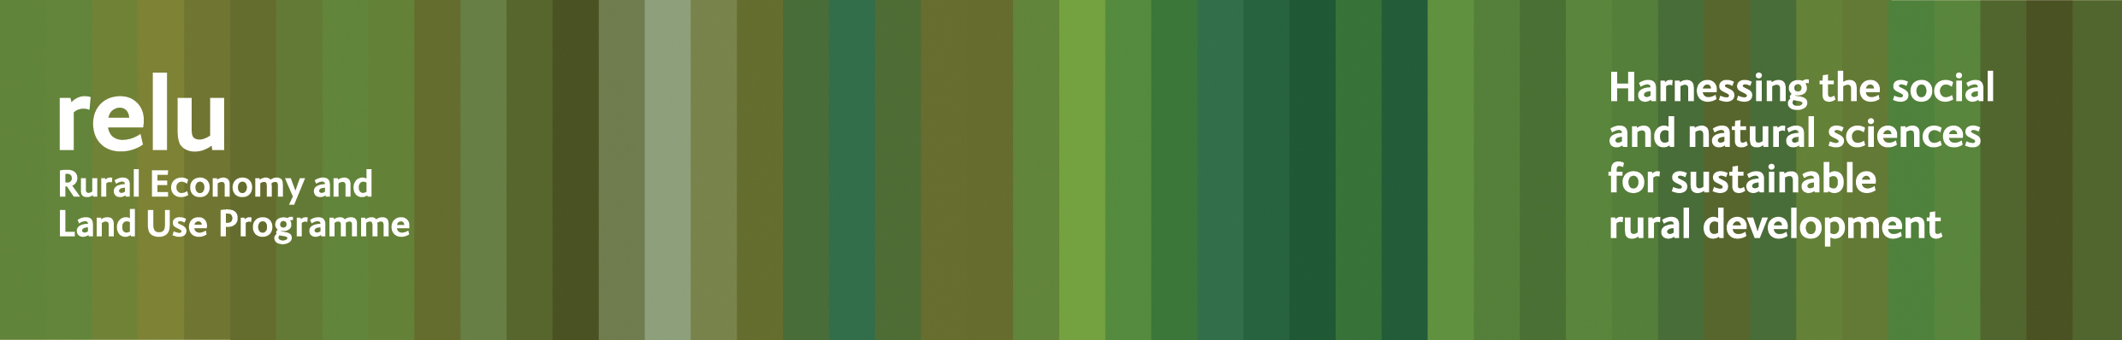
24 November 2009
Press Release

Does carbon labelling give developing countries a bad deal?

Carbon labelling could unfairly disadvantage economies in the developing world, and mislead consumers, according to an interdisciplinary project carried out by the UK Research Councils’ Rural Economy and Land Use Programme.

Researchers at the universities of Bangor and Surrey have investigated the wider implications of including details of carbon footprints on food labels. They found that current approaches to carbon labelling may not be an accurate guide to sustainability, and might have serious and unintended consequences for poorer countries.

The team has pinpointed several areas which need to be addressed. They say that schemes often discriminate in the ways they gather information. For example, the figures quoted may declare greenhouse gas emissions caused by clearing native forest for agriculture in developing countries – while crops from Europe seldom include these, because the land was cleared long ago.

On the other hand, additional carbon sequestered in soil under tree and bush crops commonly grown in developing countries is seldom shown in the carbon footprint.

The researchers emphasise that more accurate databases are needed, in order to ensure that the figures used are fair, and argue that these should be publicly available on a central website, giving detailed information about how they were gathered.

Professor Gareth Edwards-Jones of Bangor University said: “Consultants often come up with numbers without actually visiting the farms or countries involved, so they tend to work with “standard” scenarios. They may even use the same findings to calculate carbon footprints over a large geographical region, thus masking differences between individual countries and farms. It should be made clear exactly how such figures are derived.

“It’s also important to include the entire lifecycle of the product, and to give details of how each phase contributes. For example, coffee has a relatively high footprint, but consumers should realise that most of that occurs in the home, when they use energy to prepare their favourite beverage, rather than in the coffee plantation. Signing up our homes to renewable energy tariffs will benefit the planet much more than worrying about the country of origin of our food.”

The researchers also suggest ways in which developing countries could reduce their carbon footprint, including processing goods before export. Drying and canning for example, result in products with a longer shelf-life that can be carried by sea, rather than air-freighted, and add value for local producers. The methods employed may also rely more on human labour than on technology, thus using less fossil fuel.

Details about the findings are available in a new Rural Economy and Land Use Programme policy and practice note which may be downloaded from the Relu website: http://www.relu.ac.uk/news/policy%20and%20practice%20notes/Edwards-Jones.pdf

Notes for editors:
- A policy and practice note in the Relu series has now been published giving highlights from this research. It may be downloaded from http://www.relu.ac.uk/news/policy%20and%20practice%20notes/Edwards-Jones.pdf or email relu@ncl.ac.uk for hard copies.
- The Rural Economy and Land Use Programme is an interdisciplinary collaboration between the Economic and Social Research Council (ESRC), the Biotechnology and Biological Sciences Research Council (BBSRC) and the Natural Environment Research Council (NERC), with additional funding provided by the Scottish Government and the Department for Environment, Food and Rural Affairs. See www.relu.ac.uk for more information about the Relu programme.
- For further information, or to arrange interviews with the researchers, contact Anne Liddon, Relu Science Communications Manager, tel 0191 222 6880, email anne.liddon@ncl.ac.uk.

ends

